**CS273 ASSIGNMENT #4: Object-Oriented Design - Inheritance and Polymorphism**

## Group Members: __VINA LE and ANNA TRAN__ DUE: Fri, Mar 24 .

**Grade:**

|  |  |  |
| --- | --- | --- |
| **CATEGORY** | **POINTS** |  |
| PR4_Banking: Part 1 – Design  **(Please read the Heads-up Below!)** |  | 50 |
| **TOTAL** |  | 50 |

**Objectives:**

* Apply the concepts of information hiding, inheritance, and polymorphism.
* **Practice building moderately complex software from specification**.

**Design Project (this is part 1 of 2 parts to this problem)**

Create the following folder on CS1 and place your solution in this folder.

**\\CS1\Students\Your Year\Your Folder\CS273\PR4_Banking**

**Carefully read programming project 4 on page 227**

**Do not implement the banking program until you have also looked at Assignment 5.** Your implementation is not due until the next assignment (assignment #5).

**The goal for this assignment is to practice building moderately complex software from description (specification).**  This is much harder than you would think, and we can only get better if we practice doing this.

For this exercise, imagine you are in a software company, and you have been given this problem specification. The class interface defined needs to be strictly followed because of external dependencies with other software components. Other software groups depend on you to accurately following the defined classes. Furthermore, much of the code is already written by other members of your team. You job is to understand the design requirements, and complete the implementation.

I would like you to study the problem description and come up with:

1. A **requirement specification** of the software that needs to be created in your own words. This should be a short English narrative describing **what** you think the software should do, **not how it will implement** its functions.

We are writing code that resembles the operations of a bank. It contains names and personal information of the members within the bank. In addition, it should have what specific person group the member belongs in (student, adult, or senior) with the program inputting and outputting the transactions, such as withdrawals or deposits, check the balance from either checking or savings account.

1. Detailed **use cases** for ALL the scenarios you imagine the software will be used in. Look at the phone directory example in the text book (**section 1.5**) to guide you with this.
   * + - Bank Cases
         * Create new account/edit accounts
         * Get Checking
         * Get Savings
         * Get account
       - Customer Cases
         * Withdrawal from Checking
         * Deposit to Checking
         * Withdrawal from Savings
         * Deposit to Savings
         * Get Checking
         * Get Savings
2. **UML diagrams** to describe the relationship between the classes described in the problem. You do not need to describe any sequence diagrams unless you wish too.

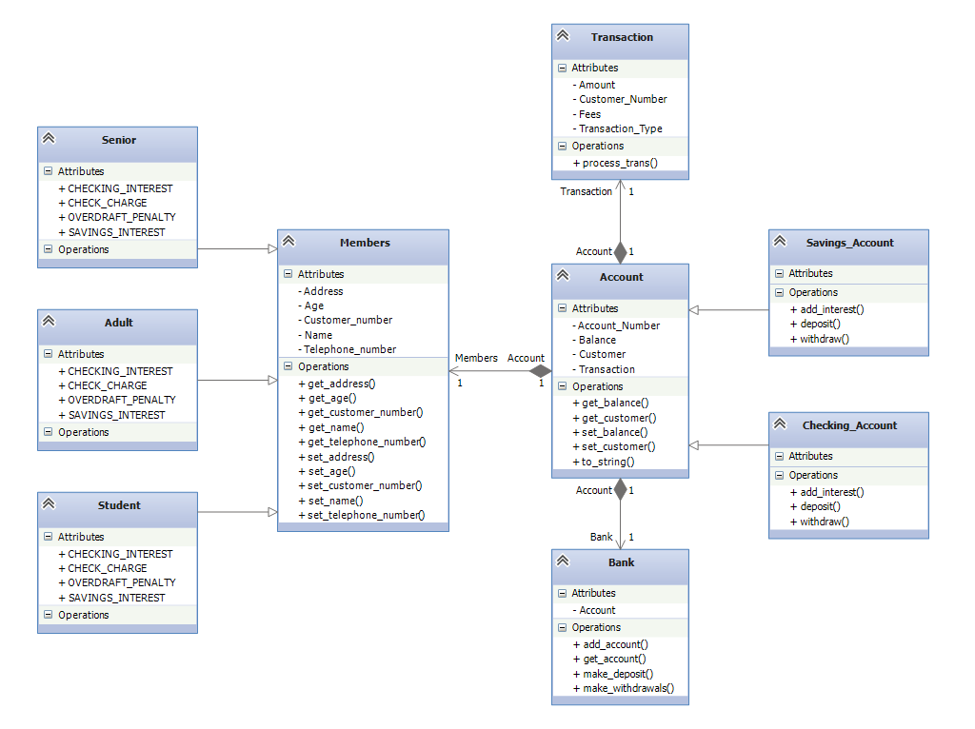

1. **Pseudo-code** to describe how the methods **add_account()**, **make_deposit(), make_withdrawal(), get_account()** in the **Bank** class will be implemented.

Add_Account

1. Prompt name
2. Read input and store name
3. Prompts for account type (checking or savings)
4. Read input from user and store it in type data field
5. Checks if user is already in the data file
   1. If in array
      1. add another account index and copy address, phone number, and age of previous account.
      2. Display new account ID
   2. if not in array
      1. Add new account to bank’s array of accounts using the name and type data field
      2. Prompt user for address, telephone number, and age to input into the account’s data field
      3. Display new account ID

Make_Deposit

1. Prompt user to enter account ID
2. Read user input into temporary data field
3. Prompt user to enter amount
4. Reader user input into temporary amount data field
5. Add amount user inputs into the account with the corresponding account ID from the account arrays

Make_Withdrawal

1. Prompt user to enter account ID
2. Read input into temporary data field
3. Prompt user to enter amount
4. Reader user input into temporary amount data field
5. subtracts amount user inputs into the account with the corresponding account ID from the account arrays

to_string

1. returns a string with info about the account, account balance, and account ID

deposit

1. changes the account balance by the specified amount.
2. Log the transaction into a transaction vector

withdraw

1. changes the account balance by the specified amount.
2. Log the transaction into a transaction vector

Find_accounts_by_name

1. Create a vector to store accounts
2. For all accounts
   1. If account name = name passed through function
      1. Add account to account vector
3. Return account vector

*find_customer

1. For all customers in customer array
   1. If customer name = name passed through function
      1. return customer object
   2. else
      1. return NULL

*add_account

1. creates a new account for a customer object with an account type
2. returns the account

make_deposit

1. finds the specified account with the account number
2. if the account exists
   1. deposit the specified amount into that account
3. else return NULL

make_withdrawal

1. finds the specified account with the account number
2. if the account exists
   1. withdrawal the specified amount into that account
3. else return NULL

get_account

1. for all accounts in account array
   1. if account number = specified account number
      1. return that account
   2. else return NULL

Please use all the design tools we have discussed in the Phone Directory example (pages 102-121). You will need to extend the design by **incorporating other properties (member variables) and methods**, but your final design must include the classes and methods described in the problem.

**At the end of this exercise, you should feel confident in implementing the solution to this problem. If you do not feel this, please go back to your design, and address your doubts.**

**Additional information for problem (programming project 4 on page 227)**

* **Class Account:**
  + **Correction**: The data field **customer** should be of type **Customer*.**
* Please use the project in**\\CS1\CS_Classdata\273\PR5_Banking\**as a starting point.
  + The project has already implemented the **class Transaction** for you
  + The project has a **main()**functionthat calls the described methods of **class** **Bank** as appropriate to implement your banking program.
  + Complete the design (and later the implementation) for **classes** **Account, Saving_Account, Checking_Account, Customer, Senior, Adult, Student,** and **Bank**.
    - A lot of the code has been written for you by previous developers on the project. Please study the provided code to see what needs to be done to complete the implementation. You’ll note that said programmers annotated their code at various locations with “FIXME”; those are the parts that you’ll need to, well, fix. The rest of the code you still need to understand; talk to Matt or Colin if you run into trouble understanding what it does and we’ll help!
    - Some of the code has not been written for you at all! If it looks like something is missing, it likely is. If you have any questions, consider Matt your client and come back to get clarification from him.
  + Note that **class Bank** has **TWO** overloaded **add_account** methods: please work out how these will be used from reading the starting code I have provided, and your **Use Cases**.

**!!! Major “Heads Up” for this assignment #4 and #5 !!!**

* **It will be helpful to work in groups of two for this part of the assignment.** Describe to each other what you think the software, classes, and methods should do. **However, in the next part of the assignment, you will need to implement your own banking program individually.**
* This is a large project and you absolutely won’t be able to finish it if you start the night before it is due.
* **Plan on at least 6 hours or more for completing both assignments 4 and 5**.
* **Design and implementation often goes hand-in-hand**. So please look at the starting code now, to understand how your design is going to co-exist with the current implementation.
* **When you are stuck, use the Visual Studio Debugger**. I have included a simple tutorial in this document that shows you how to use the debugger to understand what your code is doing.
* **Finally, the debugger is your friend!** I’ve included an excellent tutorial written by another lecturer from years gone by, but from what I’ve seen of your debugging skills I doubt if you’ll need it. Again, Colin and I are also here to help!

## Using the Visual Studio Debugger

##### Ed Walker (last updated: 9/25/2014)

Let us begin with a simple example. I have the following code in Visual Studio. The code implements a simple **swap()** function (you know the one we learned about in CS-171).

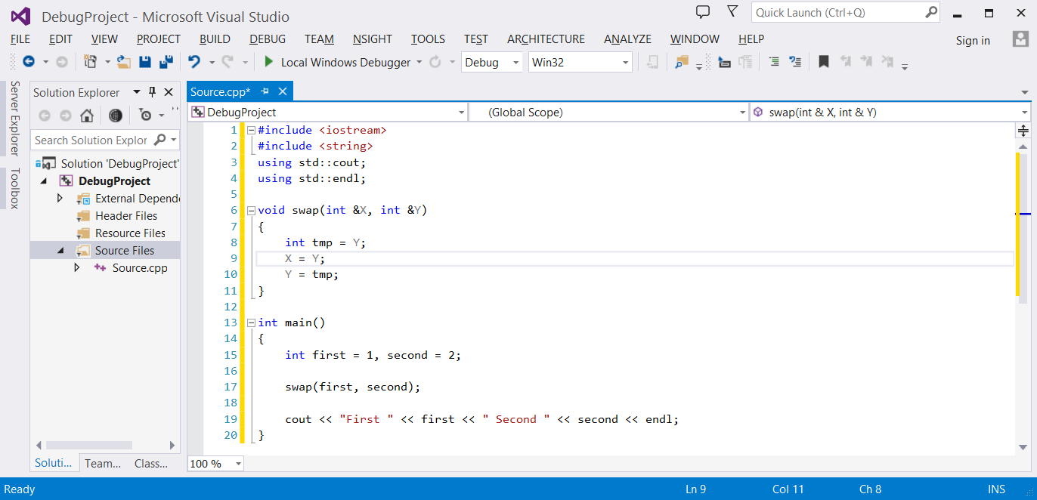

Unfortunately there is a bug in this code, because when I run it, the output is

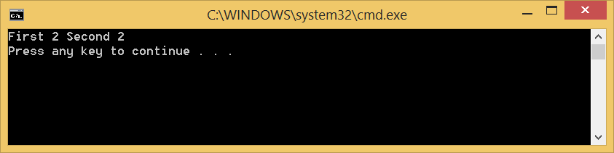

To help me understand what is going on in this program, I will use the debugger to examine the state of the program while it is running.

The first thing I will do is add a **breakpoint** in the code. A **breakpoint** is a location in the code I wish to examine when the program is running. Basically, the **breakpoint** will cause the debugger to automatically stop the program at that point when it executes.

To add a **breakpoint** in Visual Studio, I will move my mouse pointer to the location of the code I wish to examine, and click on the left gray border in the code editor window. The **breakpoint** will appear as a red dot in the gray border.

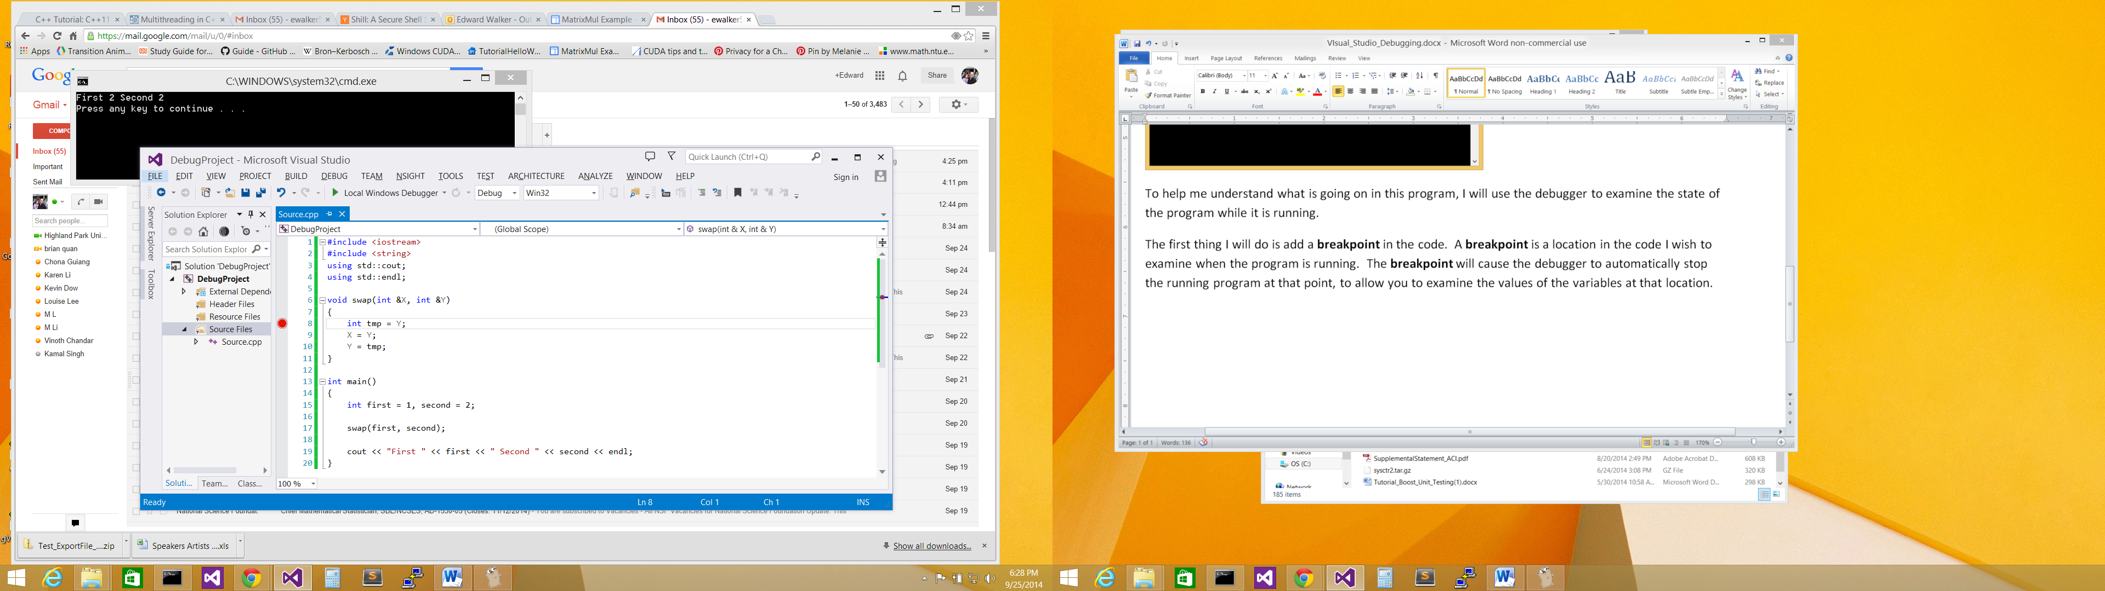

Click on border to add a **breakpoint**

Now I will ask Visual Studios to run my program until it reaches this **breakpoint**. To do this, I will select the **Start Debugging** option from the **DEBUG** menu.

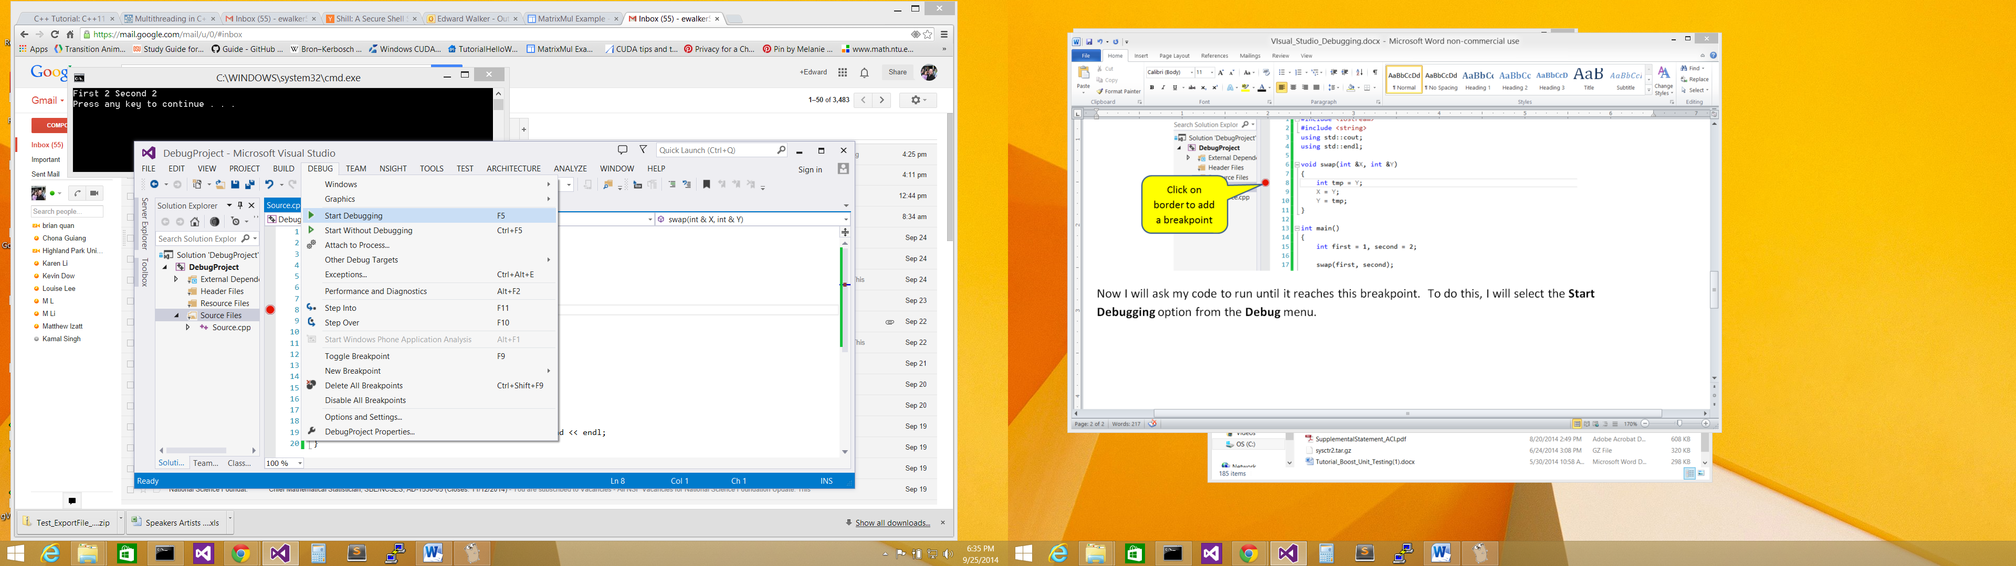

Select **Start Debugging**

This will cause my program to run until the breakpoint is encountered. Visual Studios will pause the program at the **breakpoint** to allow me to examine it. Pretty neat huh! Visual Studios will also indicate where it is currently at in the executing program with a yellow arrow on the left gray border of the code editor window.

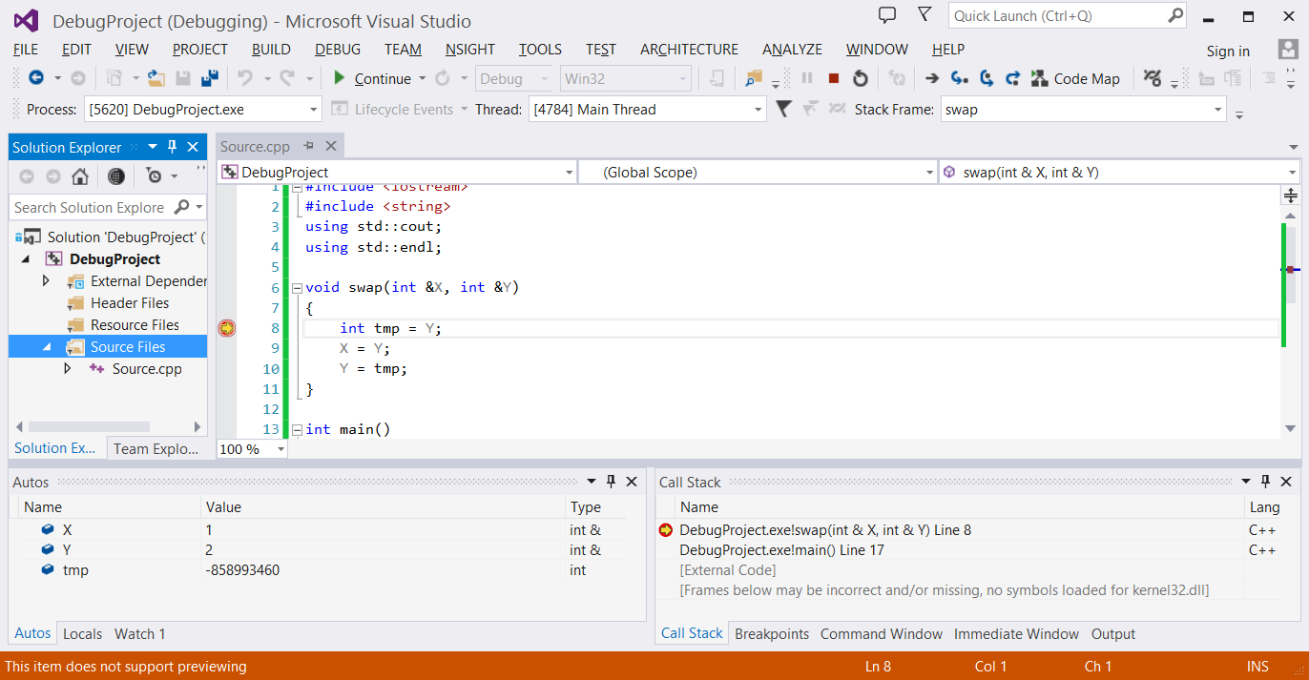

**Yellow arrow** indicates where the executing program is at!

By hovering over any of my variables, I will be able to see their values now. For example,

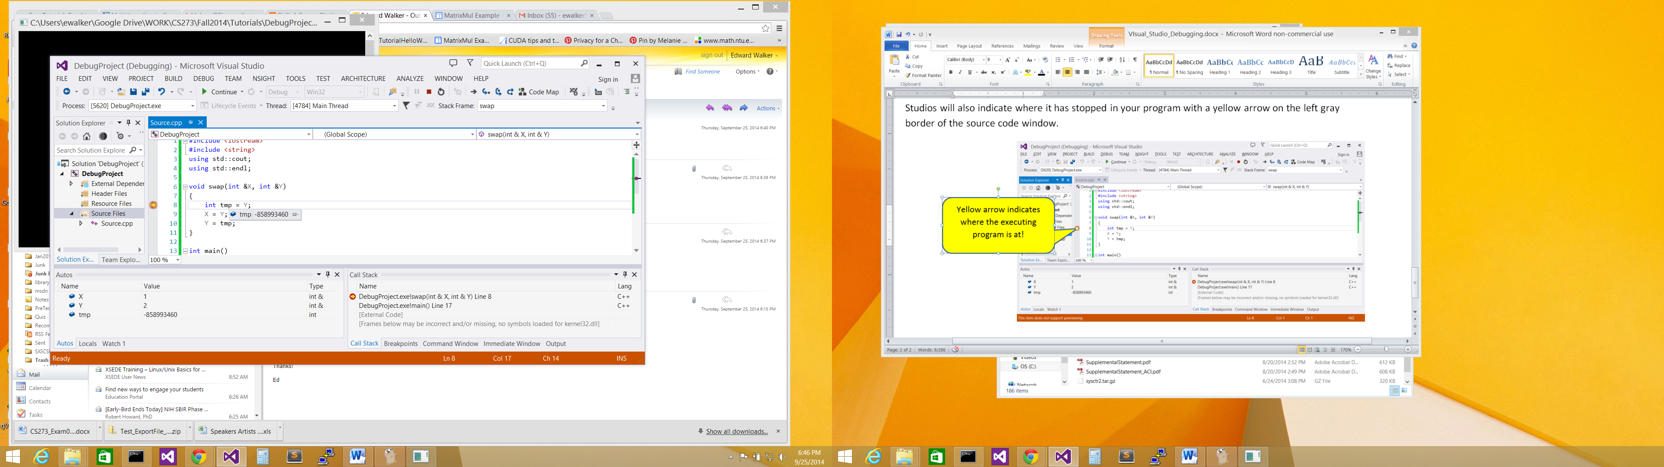

I see that variable **tmp** does not have a sensible value assigned to it yet, because the assignment statement has not been executed. If I hover over variable **Y**, it will show me that it has the value **2.**

I can also examine all the local variables in the **swap()** function by looking at the **Autos** window.

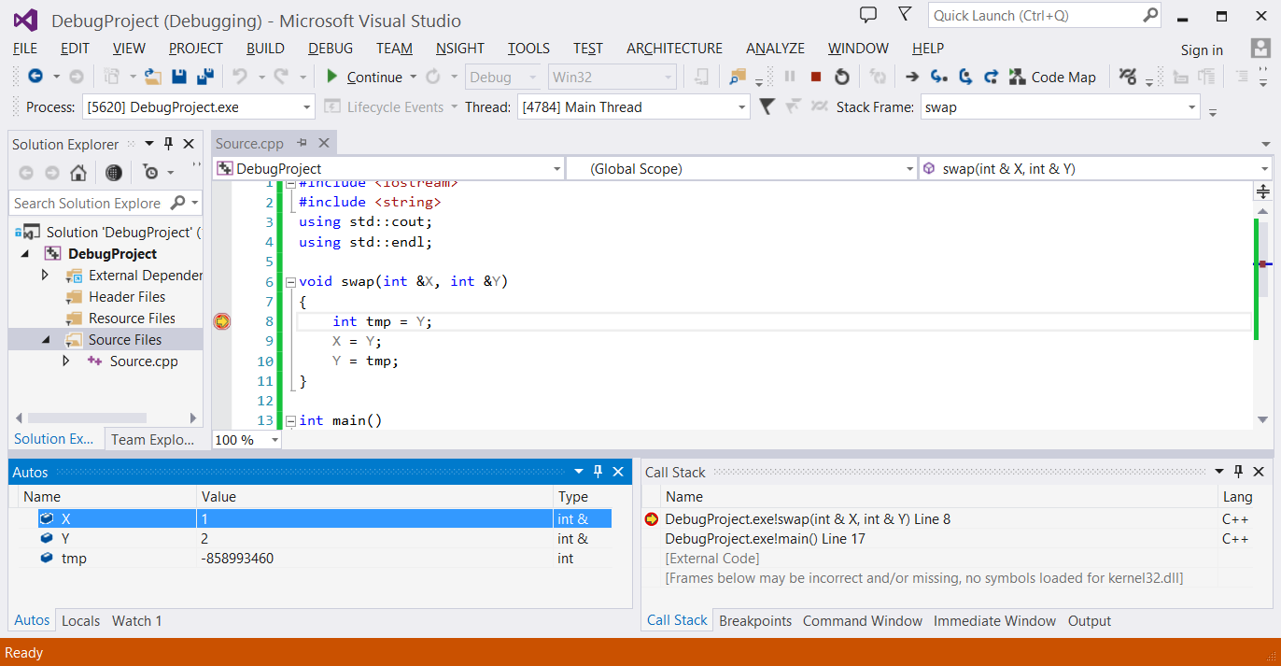

If I do not see this window, I can always open it by selecting the **Windows** **🡪 Autos** option from the **DEBUG** menu as shown below.

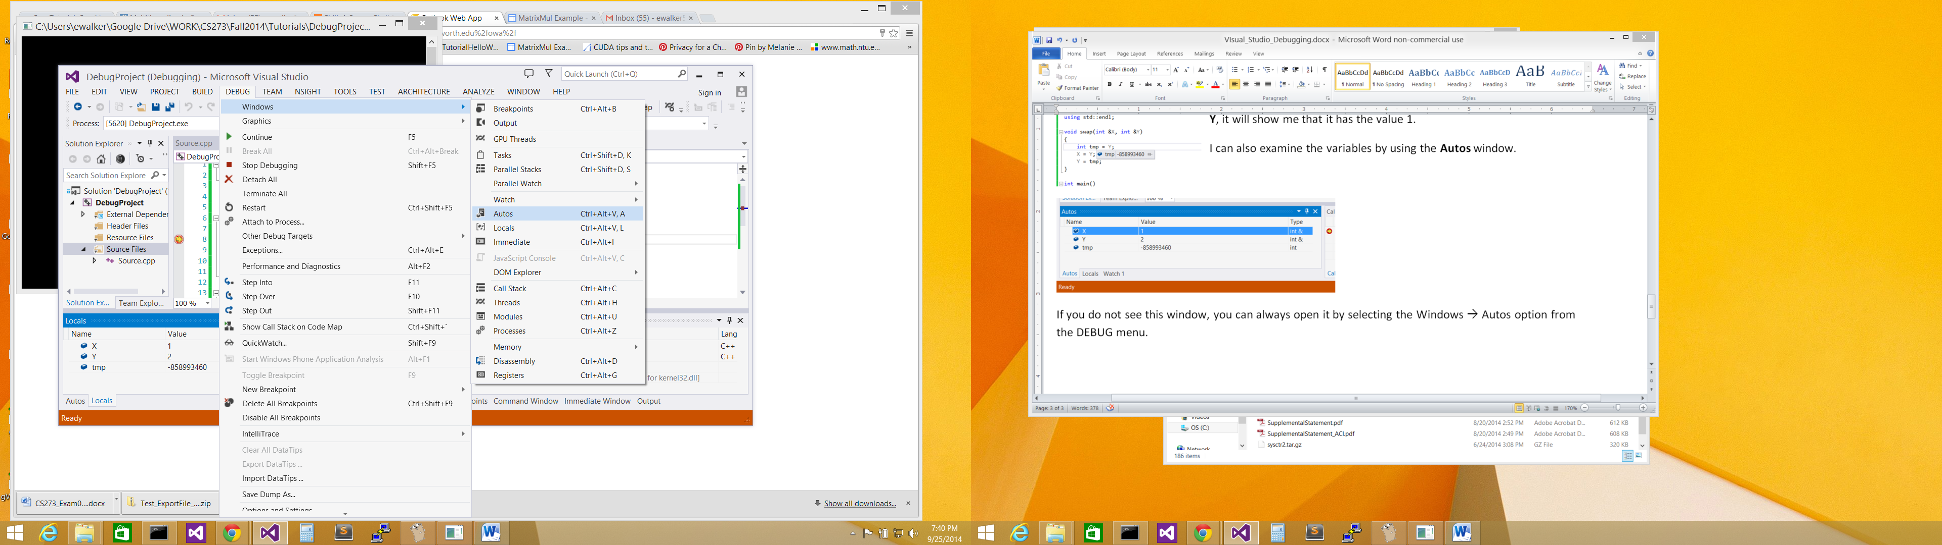

Select this to open the **Autos** window if it is not already open.

Now if I wish to step through my program, i.e. execute one statement at a time to see how my program is behaving, I will need to click on either the **Step Into** or **Step Over** button.

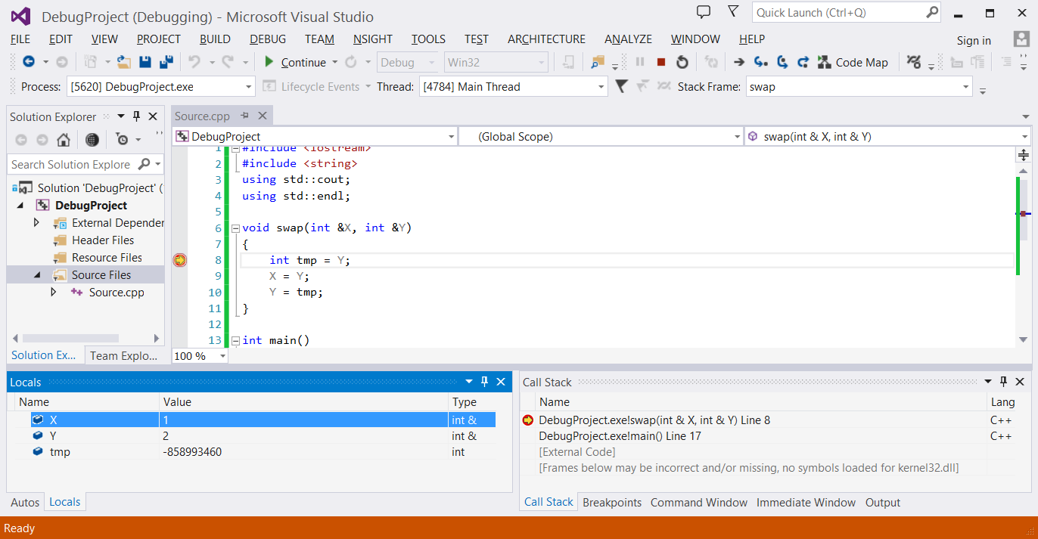

**Stop Debugging**

**Step Into**

**Step Over**

**Step Into** and **Step Over** both executes ONE line of code, but each will behave differently depending on whether there is a function being executed at that line. **Step Into** allows you to step into the function to see the next line of code in the function that will be executed. However, **Step Over** will execute the function in its entirety and move to the next line of code after your breakpoint. Because my code is not executing a function in the assignment statement I am currently at in Visual Studios, I can pick either **Step Into** or **Step Over**.

I will select to click the **Step Over** button. This will cause the assignment statement to be executed. Looking at the **Autos** window, I will see that the variable **tmp** will now have a new value of 2. I will also see that Visual Studio has highlighted the value change in the variable **tmp** by changing its color to red.

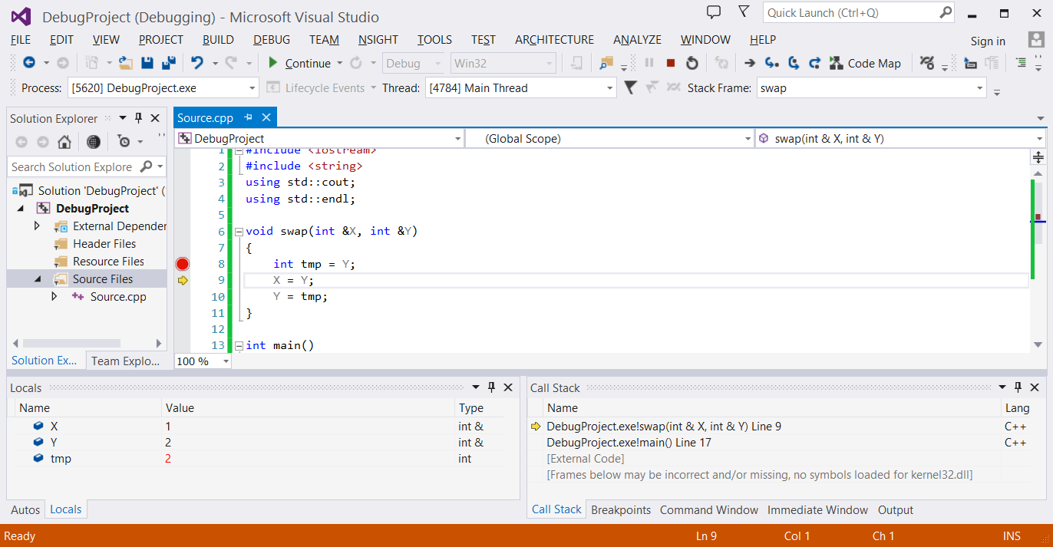

Variable **tmp** now has the value 2

Yellow arrow has now moved to the next line after the **Step Over**!

I am going to **Step Over** again to see what the next statement will produce.

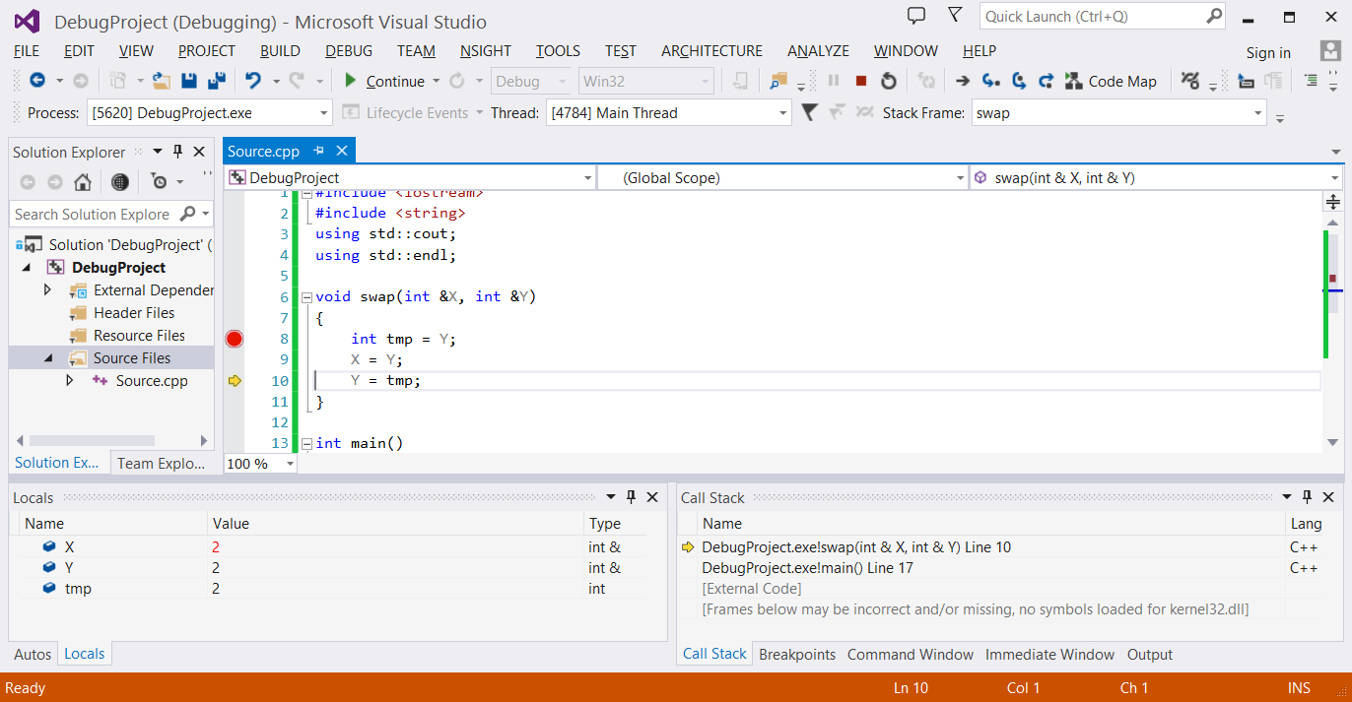

Variable **X** now has the value 2

Yellow arrow has now moved to line 10 after the **Step Over**!

Okay, I think I know where I went wrong now! I should have assigned **X** to **tmp**, and not **Y** to **tmp**, because the value of **X** is being overwritten without ever assigning its value to **Y** in the swap.

The fix is simple, so it is time to stop the debugging session by clicking on the **Stop Debugging** button.



Click **Stop Debugging**

I can now change the code of my swap function to:

void swap(int &X, int &Y)

{

int tmp = X;

X = Y;

Y = tmp;

}

Let’s us try this change out by running our program again, but this time without debugging.

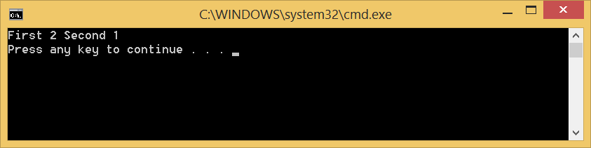

Yes I think this is a lot better!

Happy debugging CS-273!